# migrate to mimas v2 Hardware

The switch SW7 on the MIMAS V2 board (near the VGA connector) is used to switch the on-board host interface between configuration mode and UART mode.

Slide the switch to Position 1 to download bit stream through USB configuration tool. This tool can be downloaded from www.numato.com for free.

Slide the switch to Position 2 to use the interface as a UART in order to communicate from the UART peripheral on your SoC with the PC in some labs.

On the Mimas v2 board, there are only 3 digits of 7-segment LEDs. While the lab codes in this course are designed for 4 digits. Thus, the highest order digit is not used on the board. And the corresponding COM signal of this digit is connected to a floating pin described in the constraint files.

# Configure Mimas v2

MIMAS V2 configuration tool accepts only binary (.bin) bit stream created by XILINX ISE. Please follow the Steps below to generate binary bit stream from your design using ISE Web Pack.

Right click on the “Generate Programming File” option in “Processes” window.

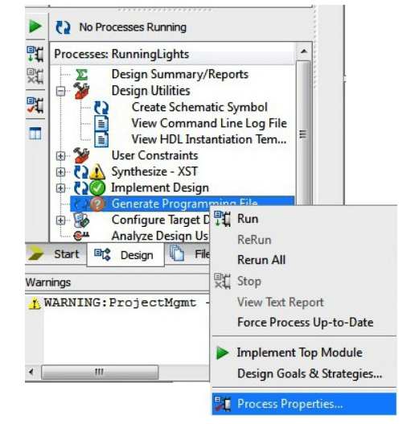

Select “Process Properties” from the pop up menu. In the dialog box, check “Create Binary Configuration File” Check box and click “Apply”.

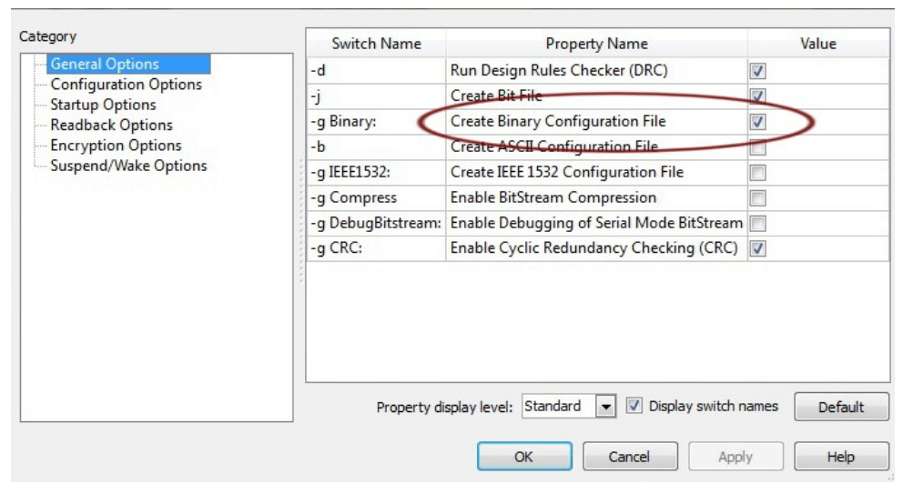

Click “OK” to close the dialog box. Right click on “Generate Programming File” option again and select “Run”. Now you will be able to find a .bin file in the project directory and that file can be used for MIMAS V2 configuration.

Make sure you have selected USB configuration mode (Slide SW7 to position 1). When MIMAS V2 is connected to PC, it shows up as a COM port in Device Manager. Run MIMAS V2 Configuration Tool and select the correct port. Click Open file button and select the .bin file.

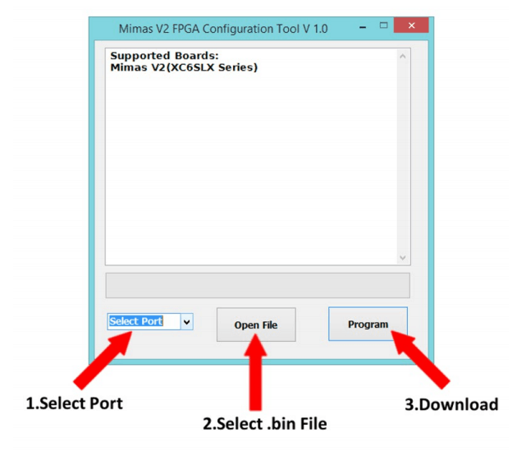

Click on “Program” button. Wait till “Done” appears on the screen.

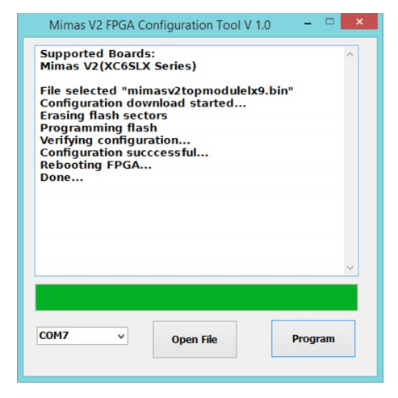

More details can be found from www.numato.com.

# download and debug software program using keil mdk

For the Cortex-M0 DesignStart r2p0, the software program can be downloaded using Keil MDK without re-configuring the FPGA hardware.

Connect the signals related to the Serial Wire Debug interface (SWDIO and SWCLK) to GPIOs on the FPGA using constraint files. For example, you can use pins on a PMOD connector like P9 on the MIMAS V2 board.

Make sure you have configured the FPGA hardware with this SoC based on Cortex-M0 DesignStart r2p0. It does not matter if the program memory is initialized with any binary program or not.

Connect the SWDIO and SWCLK pins with the host PC using a debug probe. You can use any probes that support Serial Wire Debug, e.g. Keil ULINK2, SEGGER J-Link, or CMSIS-DAP compatible probes. One available option can be purchased at: <https://l-tek.si/web-shop/cmsis-dap-debug-probe/>.

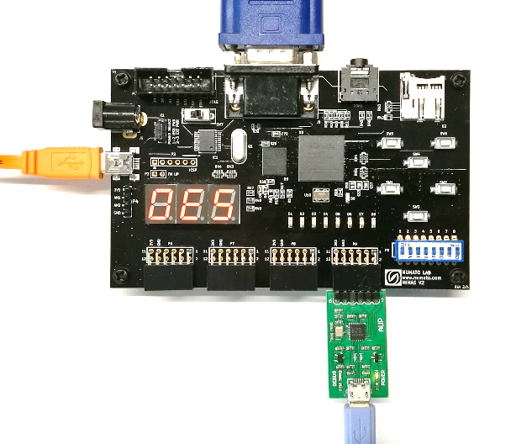

Set the target options in Keil MDK according to you debug probe.

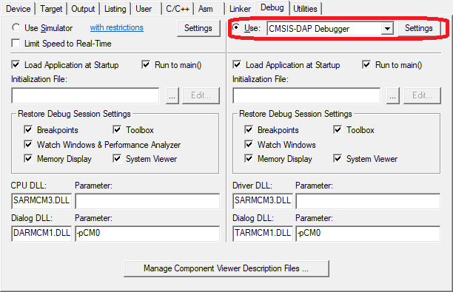

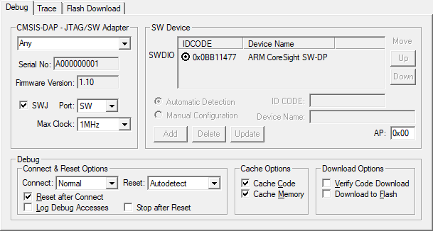 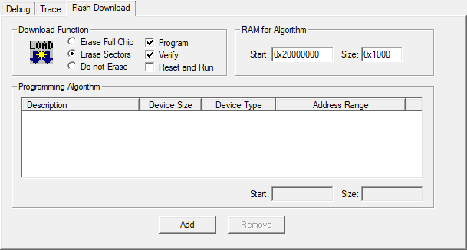

If you can see a device with a ID of 0x0BB11477, it means the Cortex-M0 system is successfully connected to you PC.

Use “Start/Stop Debug Session” button to enter the debug mode.

The software program will be automatically loaded to the program memory and halted at the beginning of your codes.

